The survey is made for project „Model of an effective visual-communication and media environment for forming and educating new audiences in the arts and cultural and creative industries through shared spaces“, „Funding competition of basic scientific research – 2018 .”, «Research fund», № КП – 06-Н 25/8

SURVEY
Your opinion is important to us! Therefore, we ask you to share your impressions, opinions and suggestions on the problems related to culture and art. By completing this survey, you will declare your commitment to a truly topical issue in contemporary society, especially related to the future of culture and arts and to raising the intellectual level of young people, forming and educating new audiences in the arts and cultural and creative industries . Answer all the questions in the questionnaire by ticking the "X" or fencing with the circle of answers that most closely matches your opinion.
The survey is anonymous! Please don't write your name!
Thank you for your participation!

1. How do you think visitors are attracted to your event?
- With the names of the participants - 1
- With the popularity of the exhibited works - 2
- With the innovative solutions - 3
- That’s how new creative ideas are born - 4

2. In your opinion, are the visitors familiar with the objects of the event?
- Rather not - 1
- Slightly familiar - 2
- Yes, they are familiar with the objects of the event- 3

3. Which institutions do you think are involved in the development, promotion and consumption of the arts, culture and the cultural and creative industries? (CCI)? (you can specify more than one answer)
- The municipalities - 1
- Ministry of Culture - 2
- Ministry of Education - 3
- Private structures …………………… - 4
- Other, which .....................................................................

4 What do you think, what is the purpose of attending your cultural event?
- With educational - 1
- With entertaining - 2
- From a common culture - 3
- Other ……………………………………………………………………………
5. In your opinion, how much do they earn from promoting arts, culture and CCIs: (use the scale and mark your answer with an "X" sign)
- The municipalities
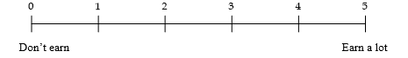
- Ministry of education
- Ministry of culture
- Other ................................................................................................

6. How do you think to what extent the number of visitors is influenced by the ways of promoting the event? (use the scale as indicated by an "X")
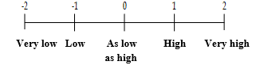

7. Where do you think visitors can be most effectively informed about such events?
- From the internet - 1
- From the radio - 2
- From publications - 3
- From billboards on the street - 4
From ………………………………………………………………………….

8. How much do you think the visitors are interested in issues related to arts and culture CCI?

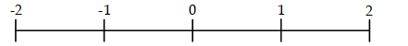
Not interested Not interested As much as, Interested Very interested
at all not so much

9. Do you think that lectures / discussions on arts, culture and CCI, at school, the University or at cultural and art institutions, forums and events contribute to the formation and education of visual culture, art and media literacy?

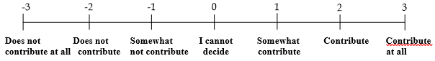

10. What is your attitude to private, institutional and public organizational structures that are involved in the production, distribution and consumption of works of art, culture and CCI?
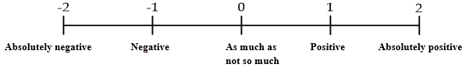

11. What is your attitude to state, institutional and public organizational structures that are designed to stimulate and promote the production, distribution and consumption of works of art, culture and CCI?

12. What is your attitude towards public-private pastoral relations between public, private and NGO organizational structures?

13. In your opinion, who are the most frequent visitors to the event?
- High school students - 1
- University students - 2
- Elderly people - 3
- ......................................... - 4
14. Do you think that conducting of cultural events, fairs and festivals have the potential to influence the development of the educational and aesthetic and artistic development and artistic activity of the individual?
15. Are there positive attitudes and practices for focused work on developing and educating new audiences through shared spaces?
16. What is your opinion on designing educational modules on the history and practice of the various arts with the education and enhancement of the skills for the distribution and consumption of cultural and art product services?
17. Do you think it is necessary to stimulate the process of developing marketing strategies and programs for research, analysis and education of users and audiences of cultural and art products and services?
You are:
- Male - 1
- Female - 2

You are _______ years old

You have been involved in this activity for ............... years.

If you have something else to share about the problems of distribution / promotion of works of art and culture, the goal of attracting and educating audiences and securing participation in the artistic life and artistic processes can be written down here . ________________________________________________________________________________________________________________________________________________________________________________________________________________________________________________________________________________________________________________________________________________________________________

